## Steps to execute PS script for Application Configuration

#### **DC Server**

#### Initial steps :

1. User must have access to AWS account.

#### Prerequisites: (we are installing it through powershell scripts)

**Following software should be installed:**

1. Redistributable
2. Native client
3. Mysqlodbc(32-bit)
4. AWS CLI

**Two buckets should be created in S3:**

1. corecard-setup-files: where all the data of core card will be uploaded.
2. application-configuration-scripts: where all the PS scripts will be uploaded under Application_Configuration_server folder.

**Detailed Automation steps:**

|  |
| --- |
| 1. Drive Configuration after attachment of an EBS Volume |
| 1. Install IIS with specific windows roles and feature [AD and DNS] |
| 1. Forest Creation and adding domain details |
| 1. Create user and add role domain user and domain admin |
| 1. Set the username and password for user |
| 1. Set the dns server in client machine and connected that machine with DC server |

**Steps to perform:**

Step1. Search EC2 & click on EC2 and then click on launch instance

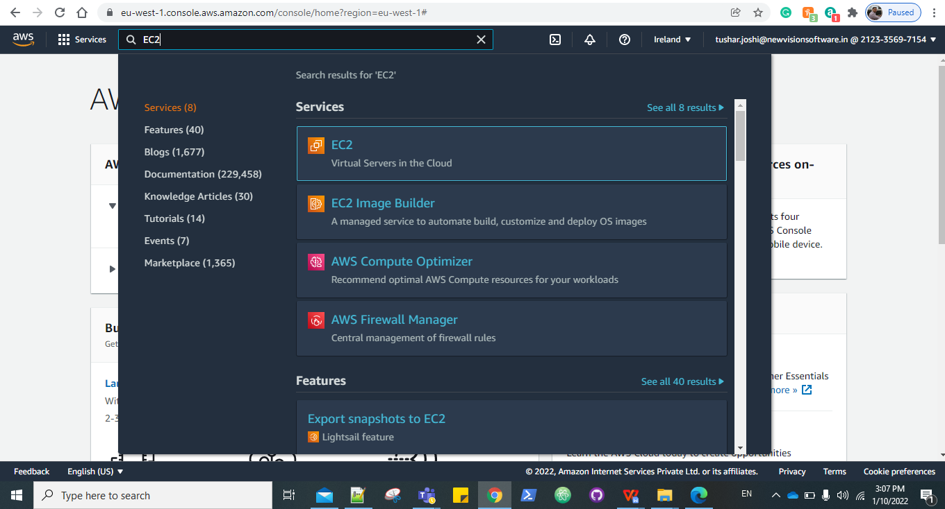

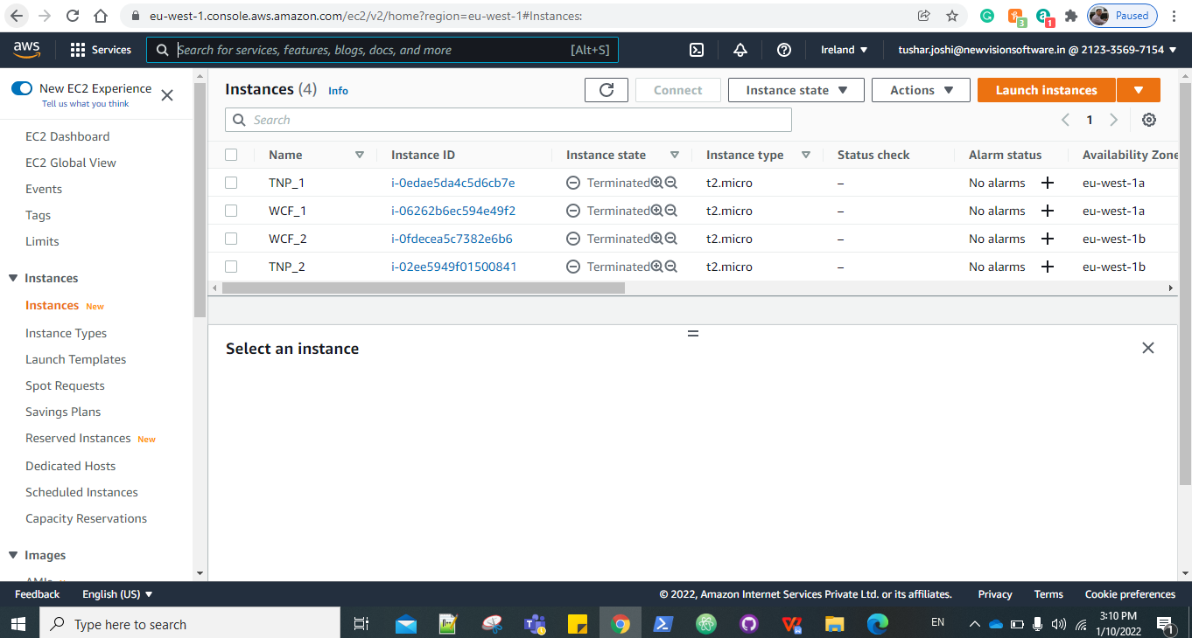

Step2.Choose Amazon machine image

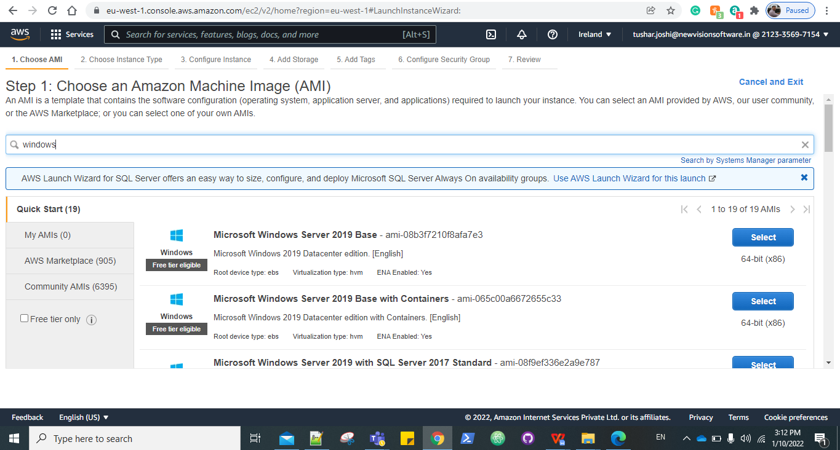

Step 3: Choose an Instance Type.

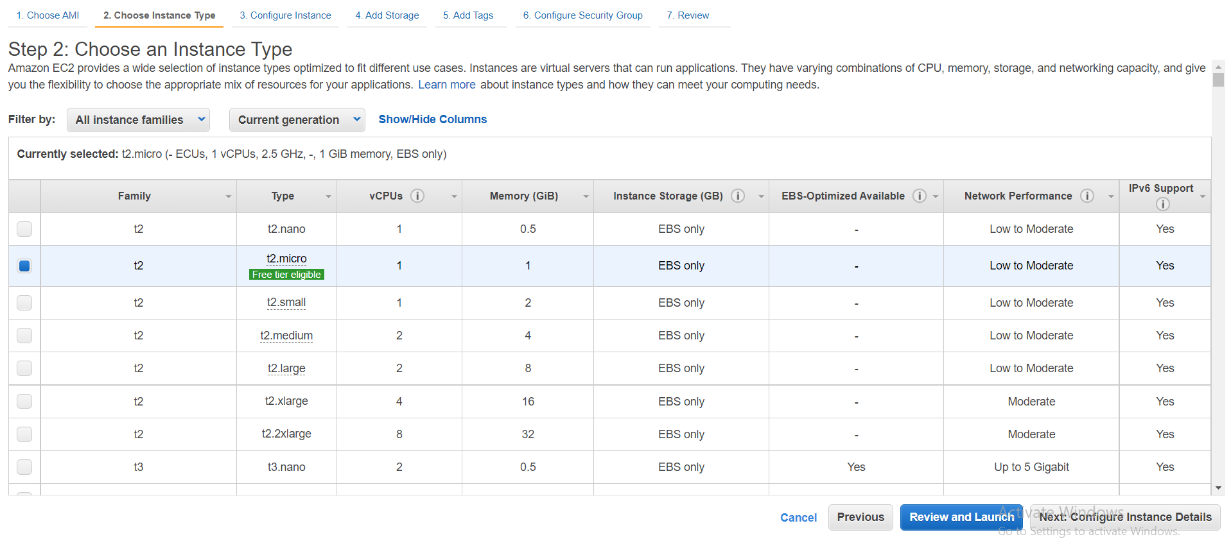

-

Step 4: In Configure Instance details select the no. of instances, DC_VPC, and in user data paste the following command:

|  |
| --- |
| **<powershell>**  **#For Application_Server**  **Initialize-AWSDefaultconfiguration -AccessKey <AccessKey> -SecretKey <SecretKey> -Region us-east-2 Copy-S3Object -BucketName application-configuration-scripts -KeyPrefix DC_server -LocalFolder C:\ -Force**  **#Hit following command after successfully copying data from s3 bucket**  **Powershell.exe -File C:\Master.ps1 </powershell>** |

Note: Enter you AWS access key and secret key ID.

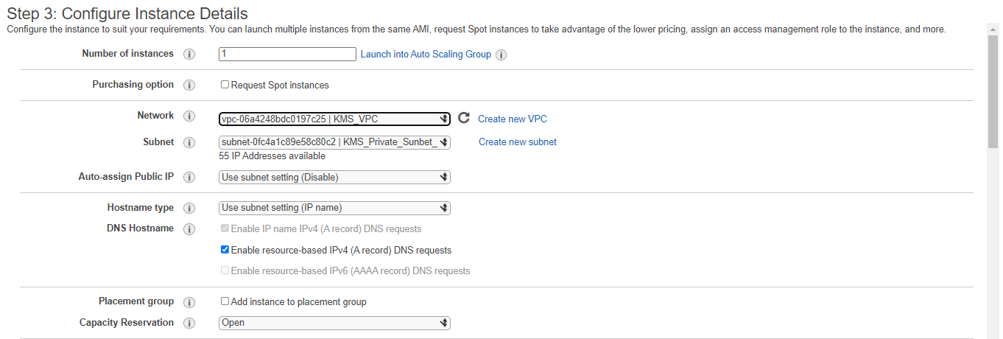

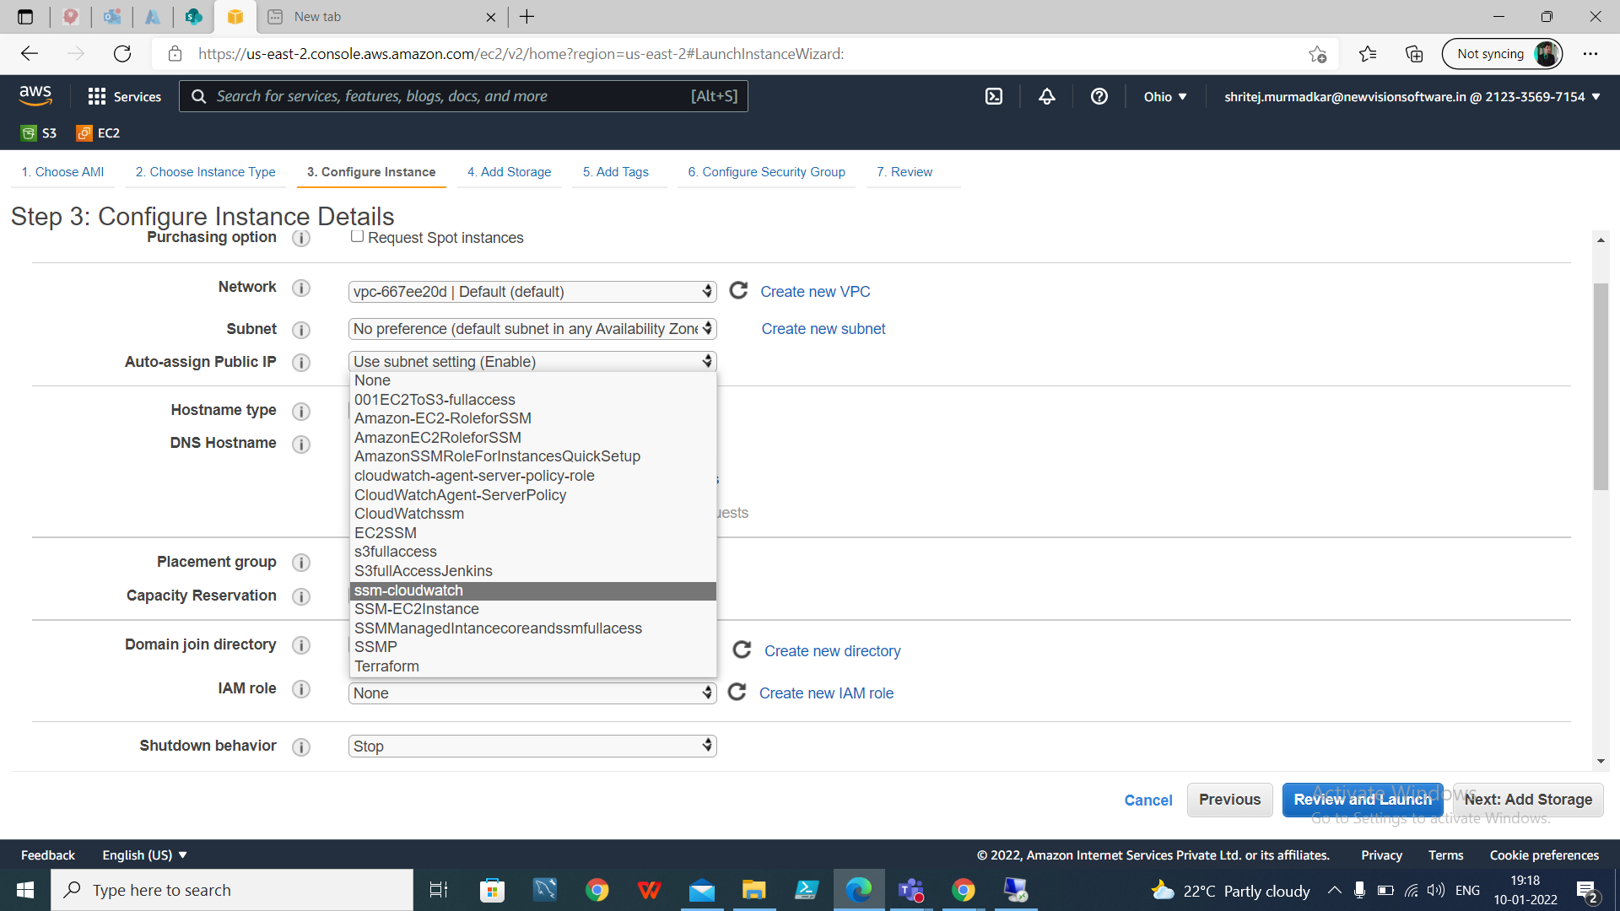

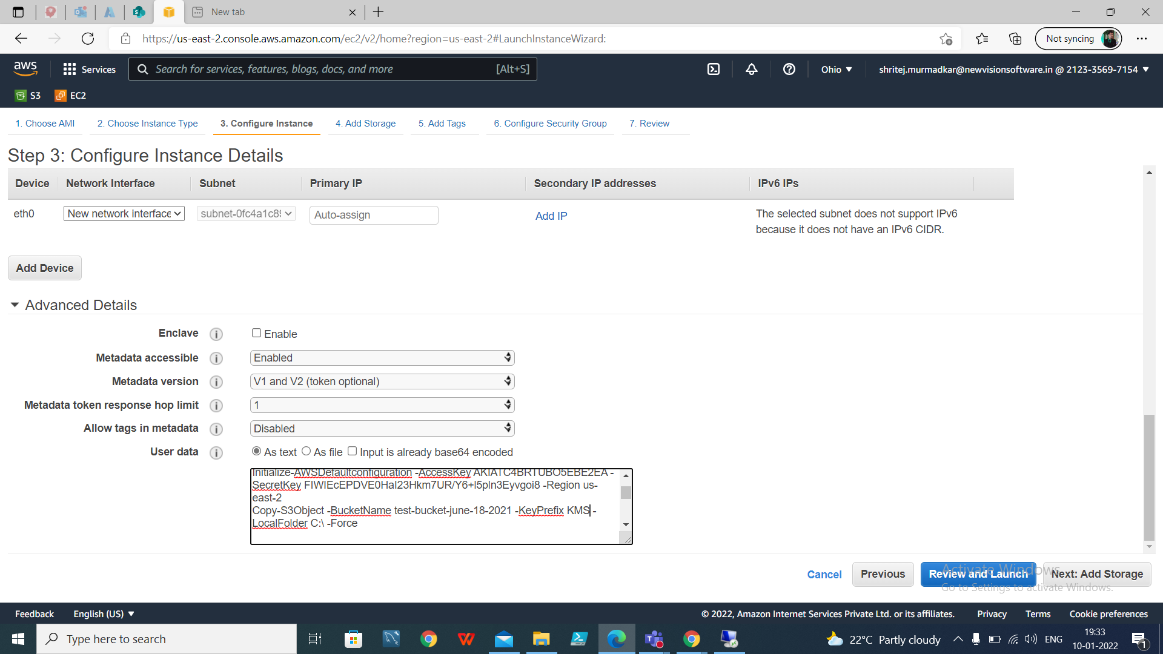

Step 5: Add storage.

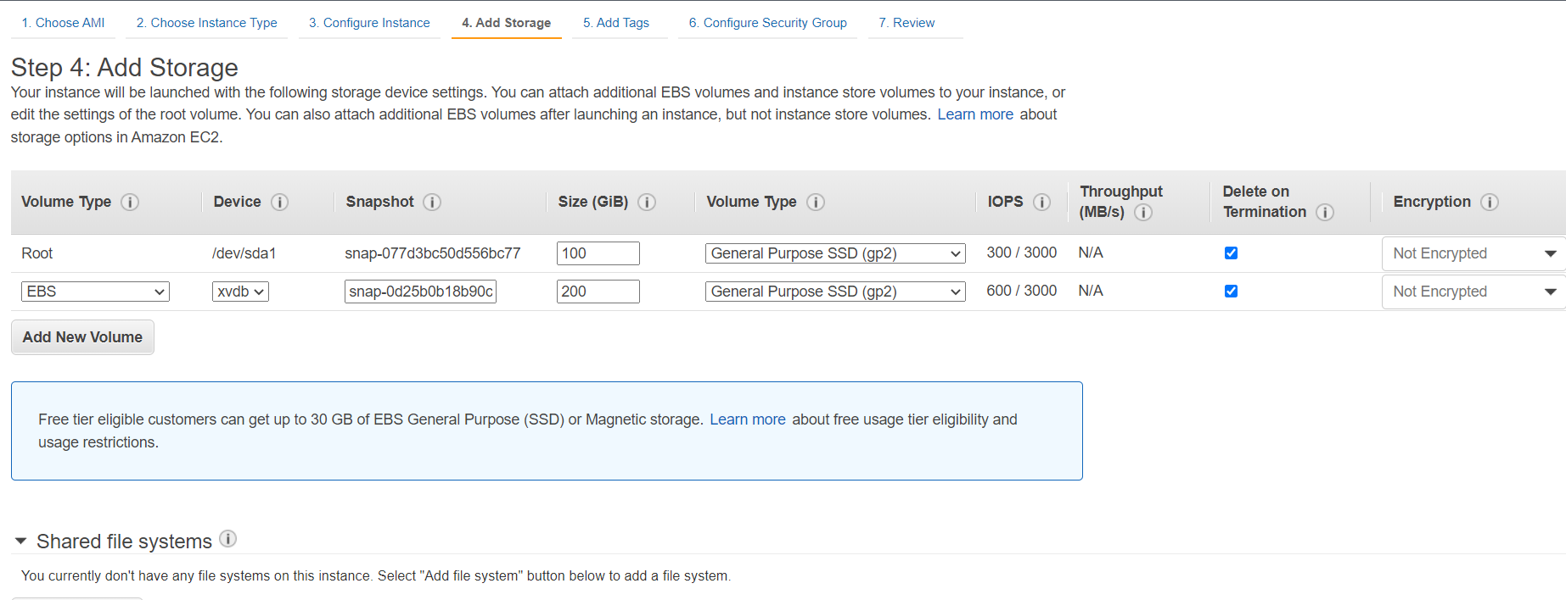

Step 6: Give the Tags if needed.

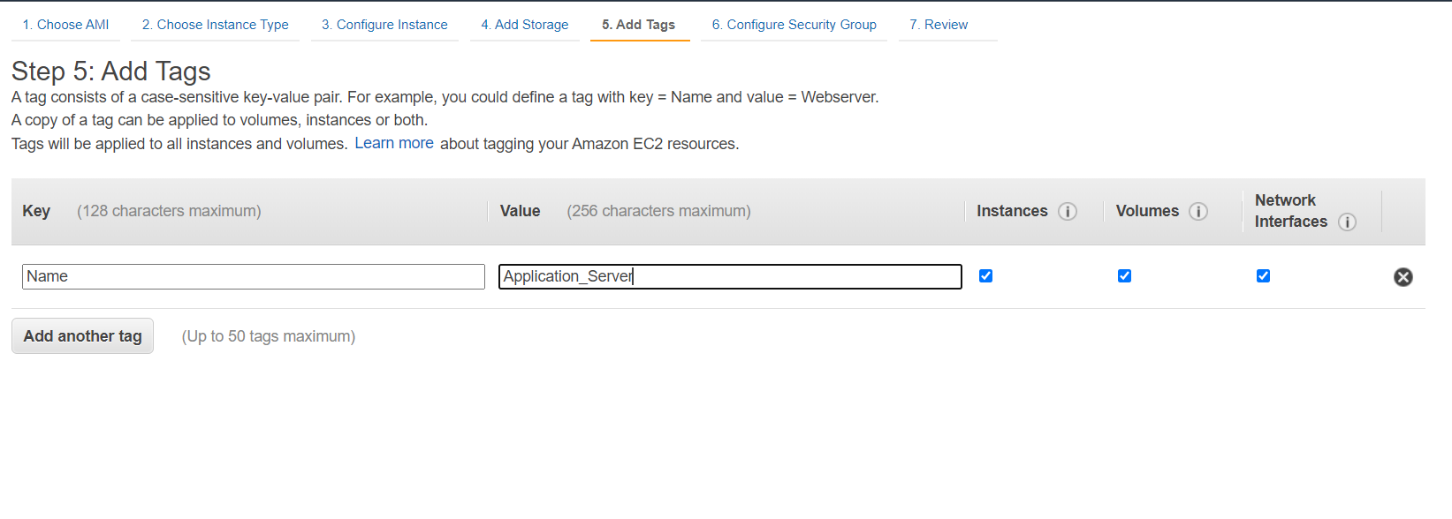

Step 7: Select the security group with name KMS_**sg**.

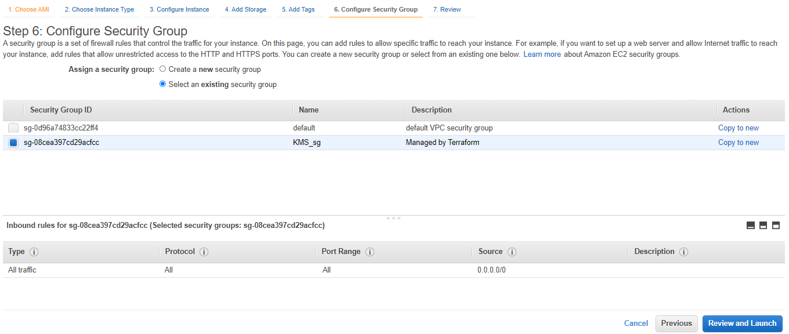

Step 8: Review and launch, Select the existing key pair or create new and launch.

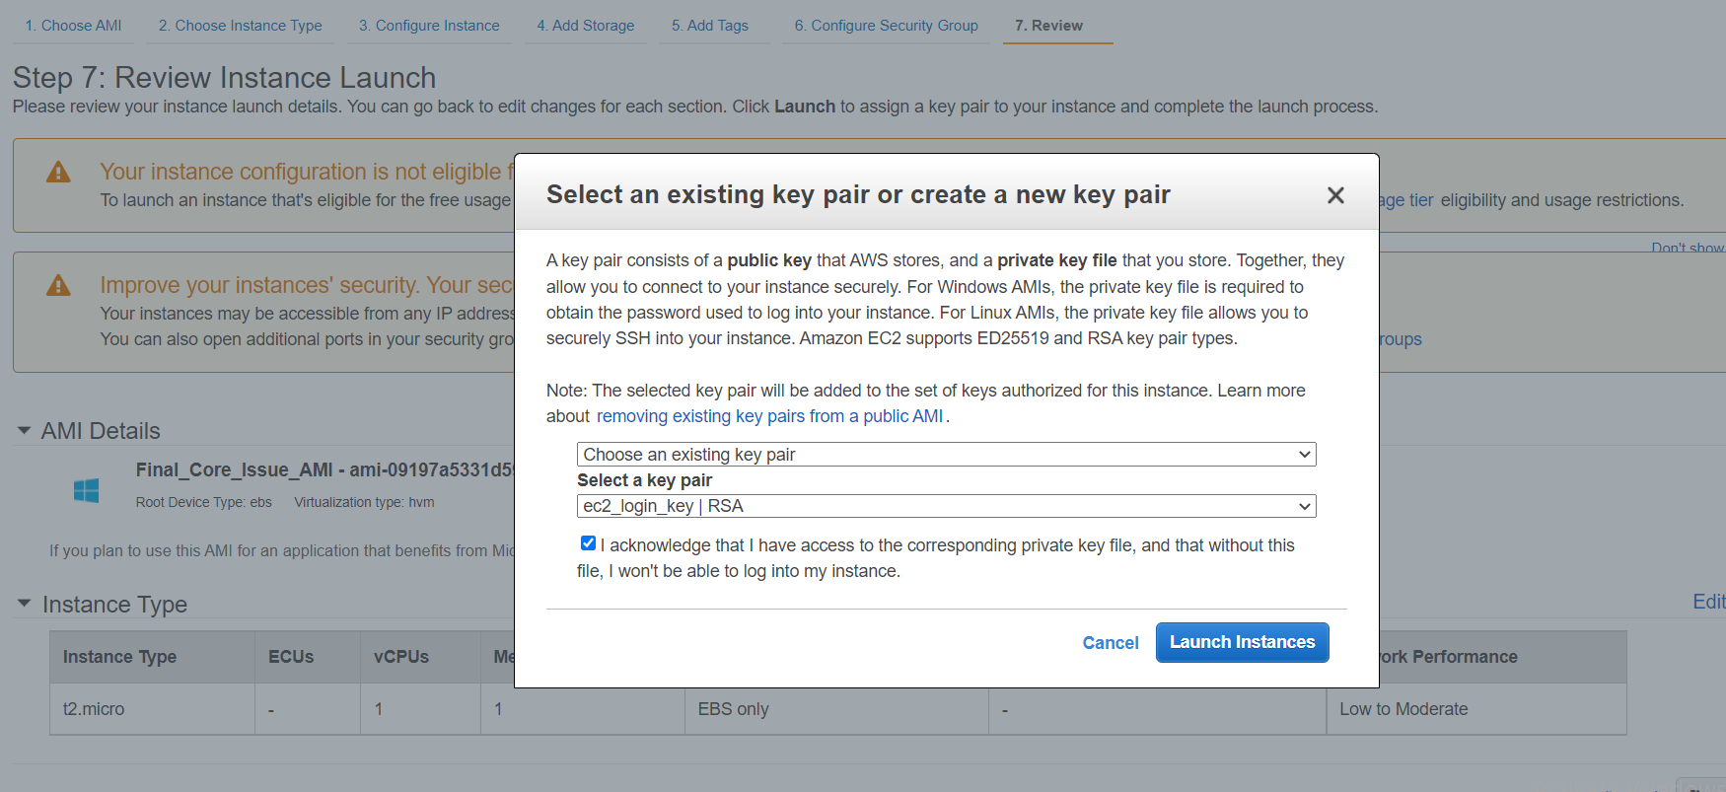

Step 9: It will take some time to configure the whole server and the scripts will be running in background.

#### **To see the output of application configuration automation:**

1. User should connect to bastion host.
2. Then, from bastion host user can connect to server through RDP.

Note: Access key and secret key to be explicitly provided in the **powershell_aws_commands** script in Application_Configuration_Server folder.